**ESTIMATION OF BUSINESS EXPENSES**

**INDEX**

|  |  |
| --- | --- |
| **S.NO** | **CONTENT** |
| **1** | **INTRODUCTION**    **1.1 OVERVIEW**  **1.2 PURPOSE** |
| **2** | **PROBLEM DEFINITION AND DESIGN THINKING**    **2.1 EMPATHY MAP**  **2.2 IDEATION AND BRAINSTORMING MAP** |
| **3** | **ADVANTAGES AND DISADVANTAGES** |
| **4** | **APPLICATIONS** |
| **5** | **FUTURE SCOPE** |
| **6** | **RESULT** |
| **7** | **CONCLUSION** |

**1.INTRODUCTION**

* 1. **Overview**
* Estimating all the expenses required to start and operate the business such as equipment, rent inventory and marketing
  1. **Purpose**
* Estimates are important because they allow businesses to set expectations for their customers.
* They also help business determine whether or not a project is feasible and how much profit they can expect to make
* Estimating also allows businesses to plan for unforeseen expenses and keep track of spending

**2.PROBLEM DEFINITION AND DESIGN THINKING**

**2.1EMPATHYMAP**

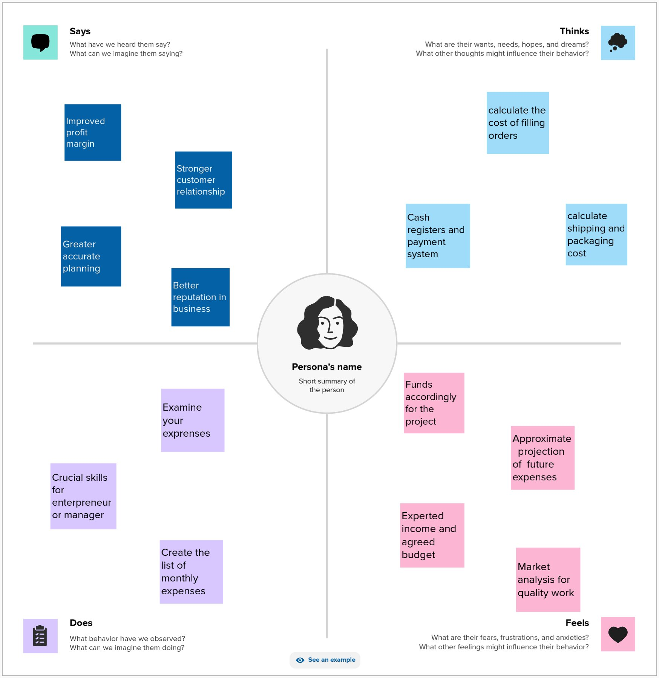

**2.2 IDEATION AND BRAINSTORMING MAP**

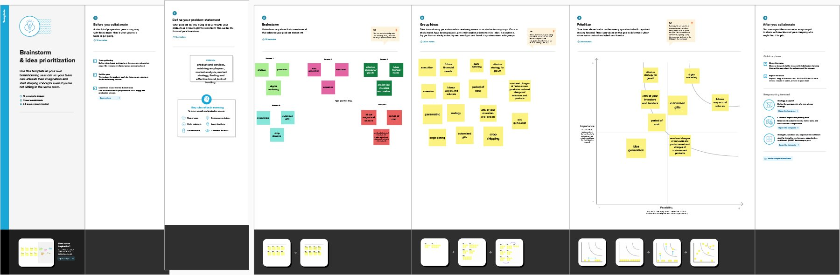

**3.ADVANTAGES**

* + The following are the advantages are merits of cost estimation accurate planning cost estimation helps predict future expenses accurately
  + Which help determine the cost of manufacturing a product increased profit margins advance information on expected expenditure helps in regulating costs

**DISADVANTAGES**

* + - It ignores integration efforts usually found in complex and large projects
    - The duration estimate depends on the cost estimate which increases the change of miscalculation affecting the overall Endeavour

**4.APPLICATIONS**

* Business applications refer to any software used by an organization to support its business processes such as CRM(customer relationship management) ERP(enterprise resource planning) HRIS(human resources information systems) and so on.

**5.FUTURE SCOPE**

* Efficient management and sufficient capital are those few key ingredients without which a sustainable and profitable business is not possible but another thing that is inevitable these days is to explore the upcoming business ideas

**6.RESULT**

* The income statement is the primary financial statement used by business to record their expenses and determine the taxes
* Most have three categories of expenses broken down by direct costs indirect cost and interest

**7.CONCLUSION**

To be successful in sustainable business practices often requires entrepreneurship and innovation this chapter provides an overview of entrepreneurship and innovation as it relates to sustainable business.